Steps to clear the caches:

- Go onto the monitor tab
- Click on the domain
- Select the resources tab
- In the resource type drop down, select Response Cache
- Select the resource to clear as shown below

Select Resource:
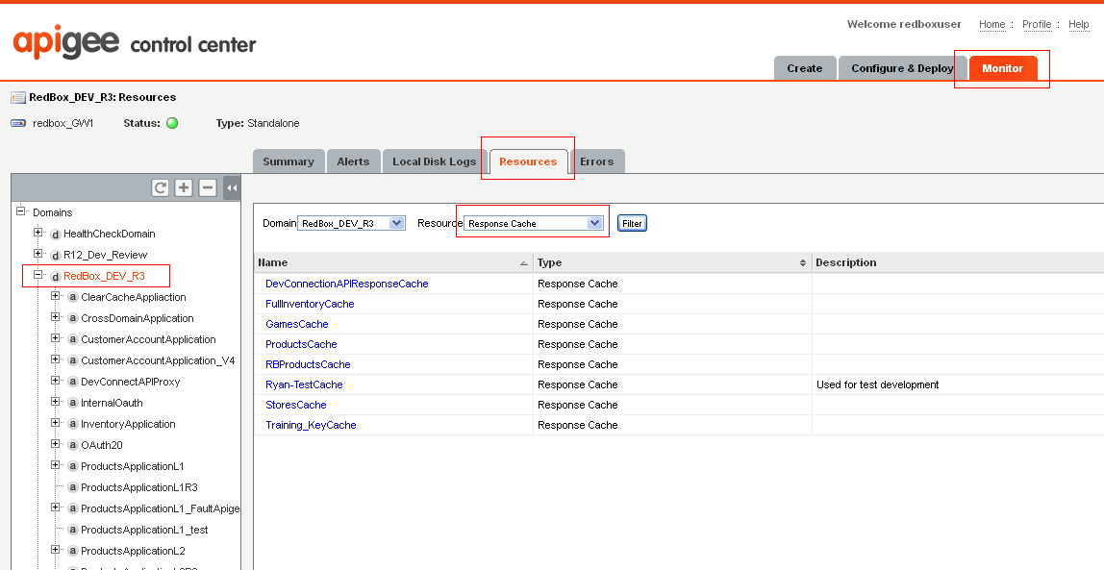

6) After selecting the resource, click on the clear cache link on the right as shown below

